

**We have partnered with C.C. Farms this year for a holiday fundraiser.** 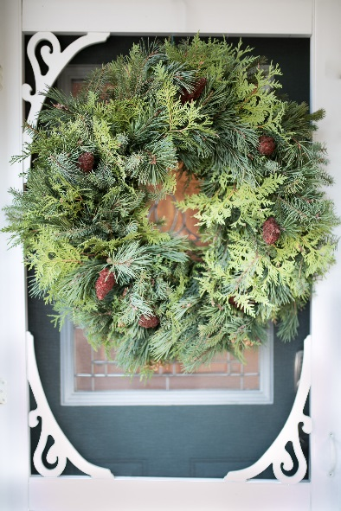

C.C. Farms

**Our family run company has been producing fresh handmade evergreen Christmas products since 1997. We specialize in fresh wreaths and planters. We make everything fresh and made to order. Nothing is prepared ahead of time. We have sold directly to the public as well as to Rona Inc. We have found that there was a great partnership for our products to be used for a fundraiser for schools and hockey teams.**

**Our wreaths are made with a base of greens, spruce, white cedar and pine. We decorate the wreaths with sumac. The wreath finishes out to approx. 20” wide and a thickness of about 5”.**

**Our planters are made in a plastic 2 gallon pot and fit well 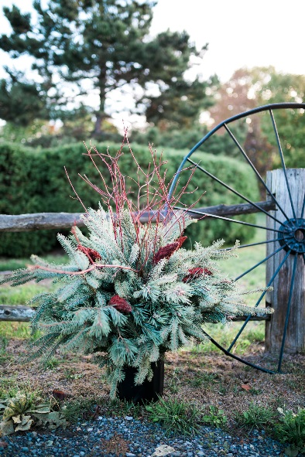into urns. They come with a variety of spruce, white cedar, white pine, and red pine (Scotch pine). They are decorated with sumac and dog wood (tall red sticks) in the center.**

**Everything is cut and made fresh from local products and these products will stay green outside until spring.**

**All orders & payments are due: November 20, 2024**

**Delivery date: December 4, 2024 at museum**

Please fill out the form on the back and submit a cash payment with your order by November 20, 2024 to the SSC table.

**Orders must be picked up at the museum during training on December 4. If orders are not picked up, they will be forfeited as we do have the capability to store or deliver. No refunds!**

*We appreciate your financial support!*

**Cadet Name:_________________________**

|  |  |  |  |  |
| --- | --- | --- | --- | --- |
| **Name & Phone #** | **Notes** | **Wreath** | **Planter** | **Total** |
| Name: Sample |  | Wreath @ $40 each | Planter @ $40 each | $80.00 |
| Phone #: 613- 555 1212 |
| Name: |  |  |  |  |
| Phone #: |
| Name: |  |  |  |  |
| Phone #: |
| Name: |  |  |  |  |
| Phone #: |
| Name: |  |  |  |  |
| Phone #: |
| Name: |  |  |  |  |
| Phone #: |
| **Totals of each** |  | Wreath $40 **x**  **_______= ______** | Planter $40 **x _______= _______** | **$** |

***51 Canada Aviation and Space Museum Air Cadet Squadron (51 Squadron) is one of 440+ Royal Canadian Air Cadet Squadrons in Canada and the first one to be established in Ottawa. The Cadet Program provides youth aged 12 to 18 with opportunities to participate in a variety of fun, challenging and rewarding activities. Cadets learn valuable life and work skills such as teamwork, leadership and citizenship preparing them for their transition into adulthood. Many cadets are high achieving students that go on to become Canada’s future leaders. 51 Squadron provides a wide range of interesting and educational activities for your teenager, which would not be possible without your support.***

***Donations can be made directly to the squadron. Cheques can be made out to “51 CASM Air Cadet Sqn” or eTransfers can be sent to:***[***51.treasurer@cadetsair.ca***](mailto:51.treasurer@cadetsair.ca)***. 51 Squadron is a registered***[***not-for-profit group***](https://apps.cra-arc.gc.ca/ebci/hacc/srch/pub/dsplyRprtngPrd?q.srchNm=51+squadron&q.stts=0007&selectedCharityBn=123613523RR0031&dsrdPg=1)***and can supply charitable donation receipts. Tax receipts can be issued for monetary and for in-kind donations at/over $25.***